6.Aggregate Functions

Count total number of students:
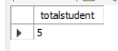
Sum of ages:
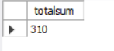
Average Age:
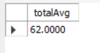
Minimum Age:
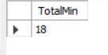

Maximum Age:
